OSCE 8/2016 by TKOH

Q1. M/60, chronic smoker
complained on and off Right side headache for 3-4 months
also diplopia, worst on right lateral gaze
no fever / injury / vomiting / dizziness
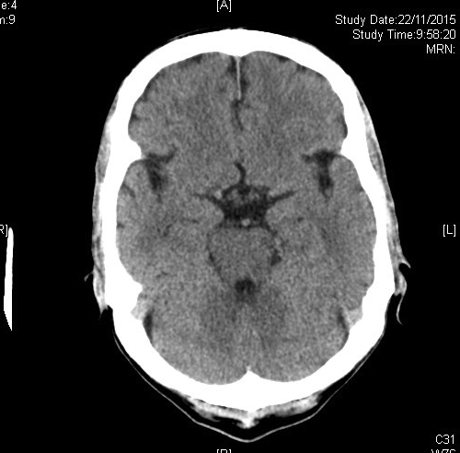
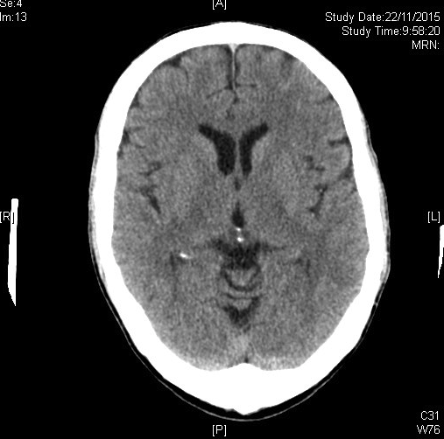
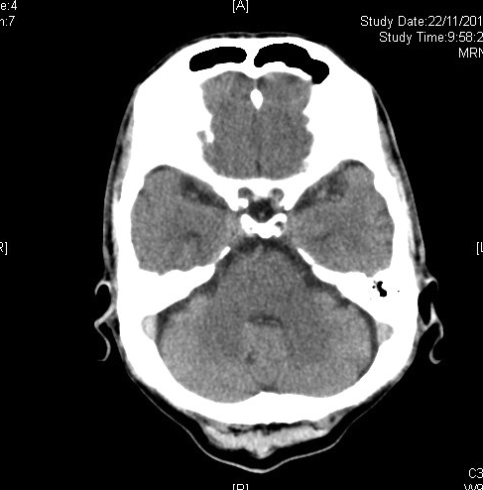

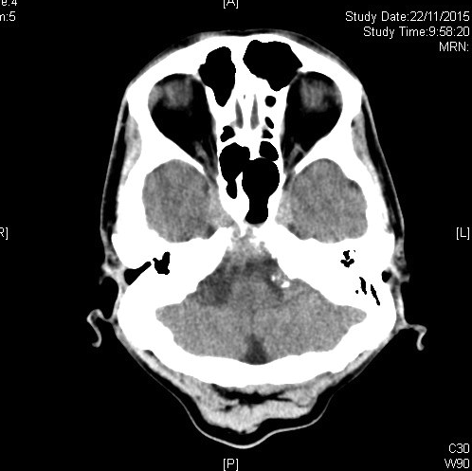
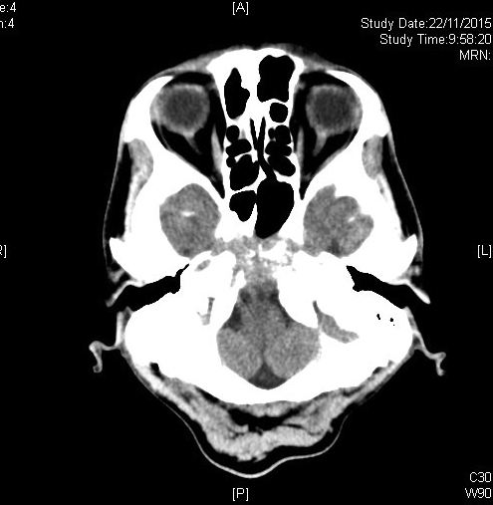

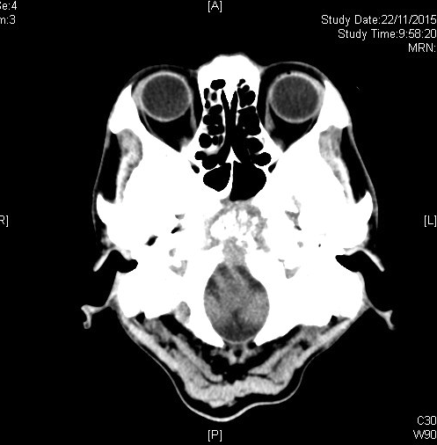

1. What are the abnormalities in the CT Brain?
Soft tissue mass with erosions seen within clivus and anterior basi-occiput. Floor of sphenoid sinus is also eroded.

2. What is the most likely diagnosis?
Nasopharyngeal cancer with bone invasion.

3. What are other differential diagnosis?
Osteomyelitis or lymphoma.

4. After assessment by neurologist and ophthalmologist, there was right lateral gaze palsy.
a) What is the total number of extra-ocular muscles for right eye?
b) Which extra-ocular muscle was responsible for the right lateral gaze? Which nerve was involved?
c) What are the possible causes for the nerve palsy?

a) 6.
b) Right lateral rectus muscle, right abducens nerve.
c) More common: Vasculopathic (diabetes, hypertension), trauma

Less common: Increased intracranial pressure, giant cell arteritis, cavernous sinus mass (e.g. meningioma, Brain stem tumor, metastasis), multiple sclerosis, intracranial hypertension, tuberculous meningitis.

Q2. F/70, known HT, ↑lipid, ESRF on HD
complained of sudden onset central chest pain for 1 hr, radiate to left shoulder, which non-exertional, no fever
BP: 105/55, SaO2, 95% on 2LO2, ECG: sinus tachycardia 110/min

CXR in this admission
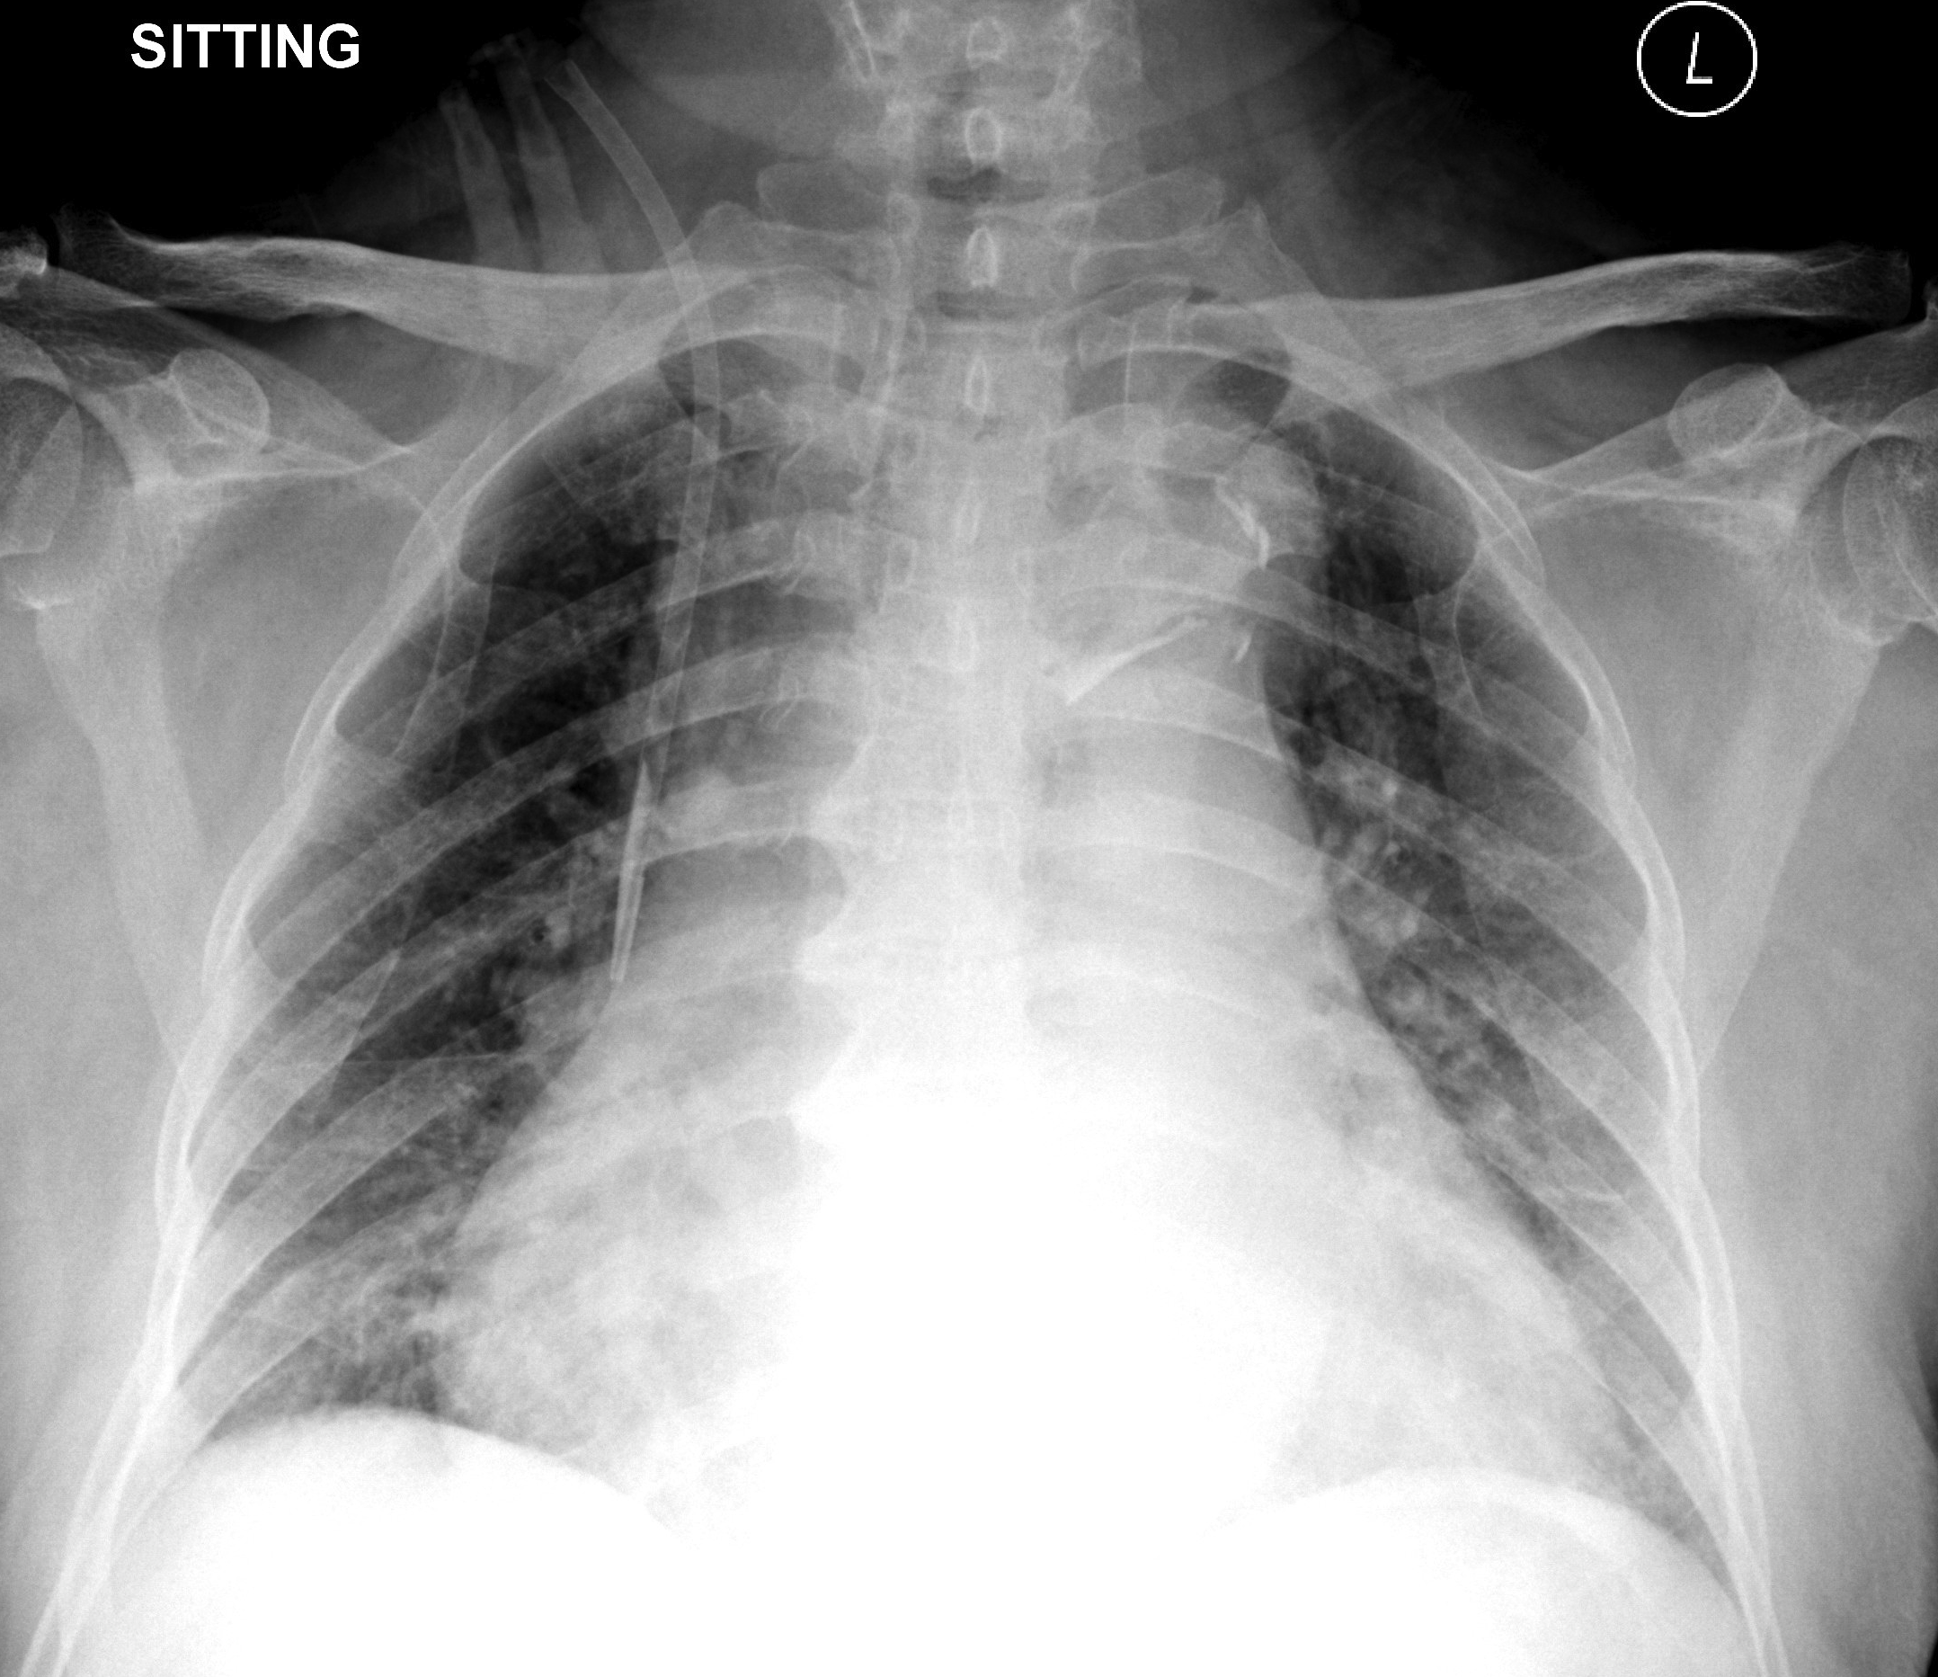
This is the CXR taken 1 month ago:
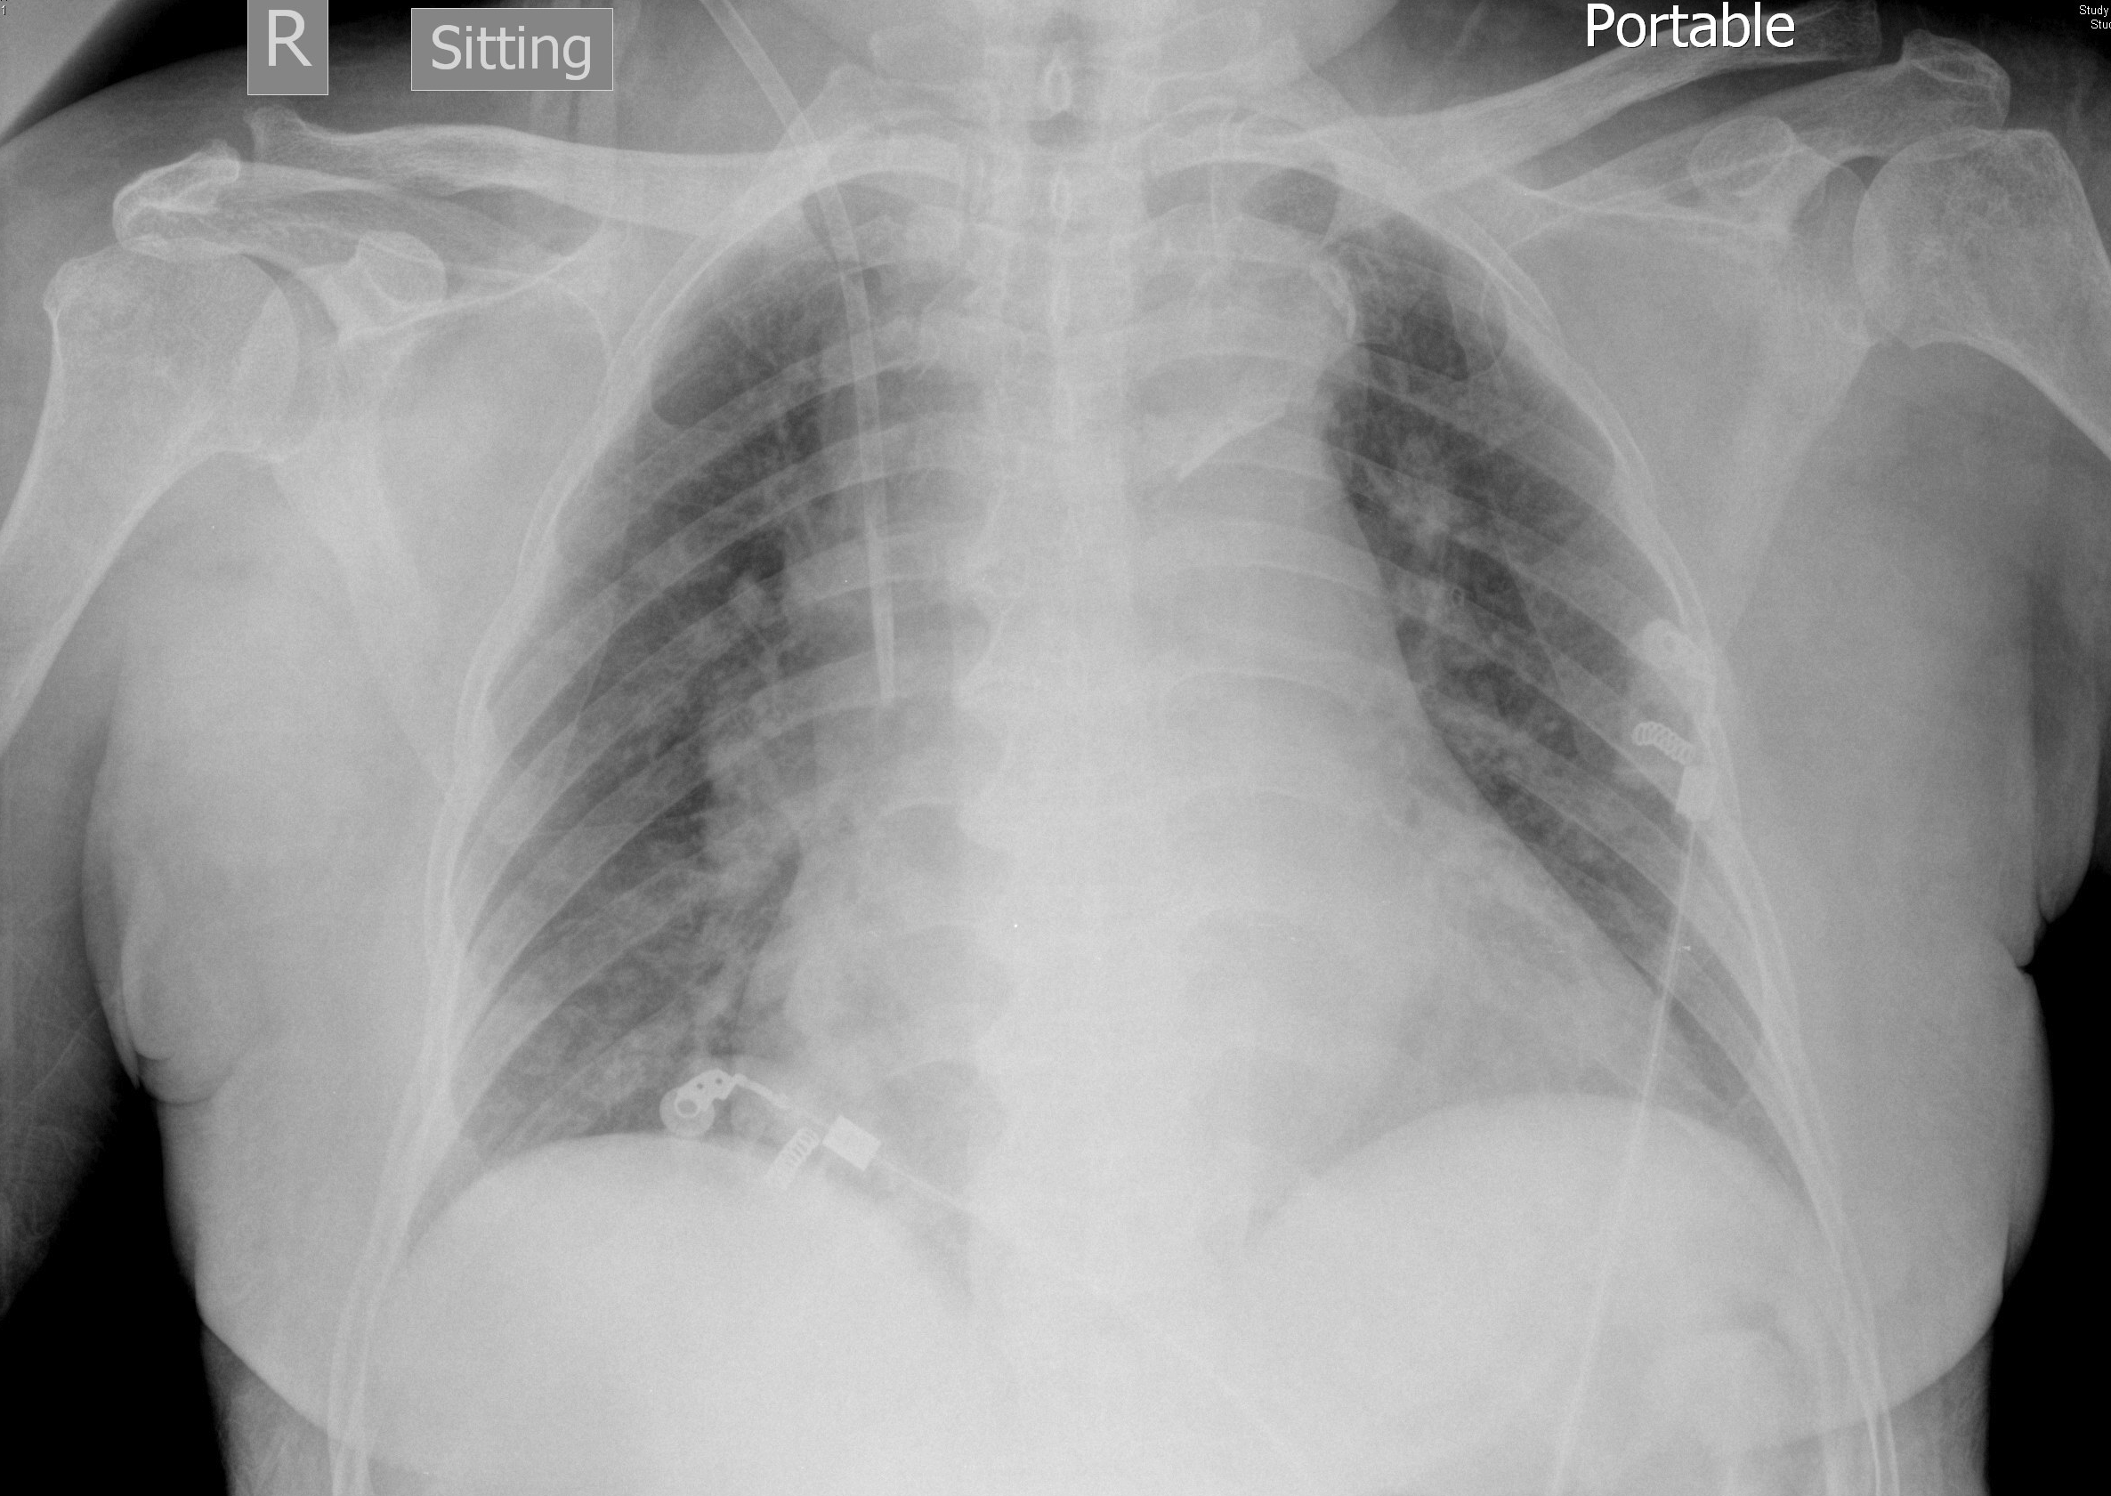

- What are the abnormalities in the CXR in this admission?
Widen mediastinum, calcium sign, right blunted CP angle

- What is the diagnosis?
Aortic dissection

- What are the other x-ray signs for this condition? Name 3.
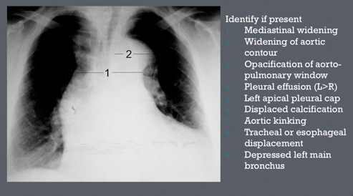

- What further investigation should be done?
Contrasted CT aortogram
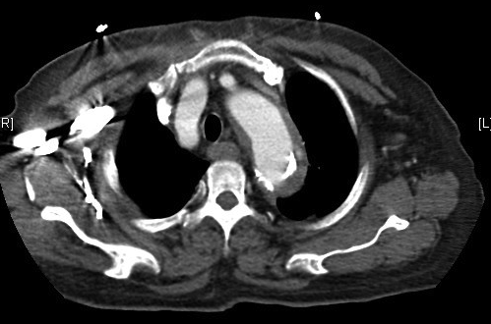

- Name a classification system for the condition.

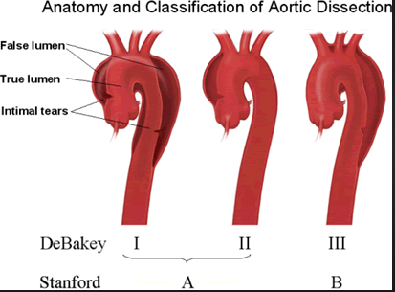

http://www.surgicalnotes.co.uk/files/images/a_dissection.gif

Q3. F/60, known bilateral renal stones FU Urology.
Left lower pole renal stone with extracorporeal shockwave lithotripsy (ESWL) was done 1 week ago, complained of persistent left loin pain since ESWL, no fever
KUB was done:
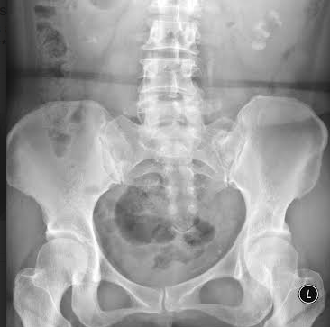
- Please describe the x-ray.
Bilateral renal stones, (left >right), multiple stone fragments lining up the left ureter.
2. What is the term for the finding over left ureter?
Steinstrasse (literally means “stone street” in German)
3. What are the treatment options for this condition?
*Mostly by conservative management. Other options: repeat ESWL, PCN, ureteroscopy, open surgery.
4. What are the possible complications?
*Infection, obstructive uropathy, renal function impairment,
and no progression of stone fragment.

* Steinstrasse after extracorporeal shockwave lithotripsy: aetiology, prevention and management. BJU Int. 2001 Nov;88(7):675-8.
Q4. M/50, smoker drinker, known DM / HT
attended AED for headache, dizziness and blur vision
no weakness / injury/ fever, no vomiting, no eye pain/ redness

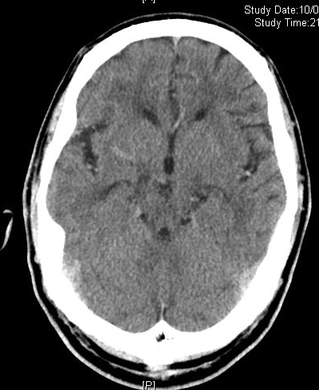
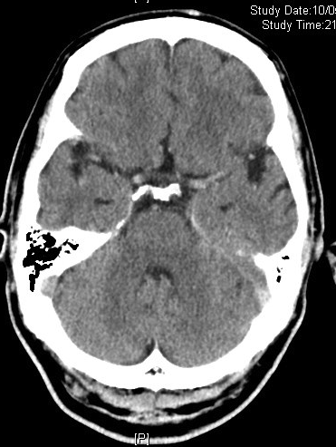
CT brain was done:
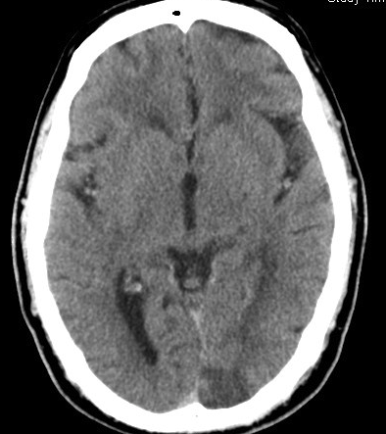

1. Please describe the CT brain abnormalities.
Diffusely dense intra-cranial arteries and dural venous sinuses.
Left occipital lobe infarct / hypodensity

CBC was shown:
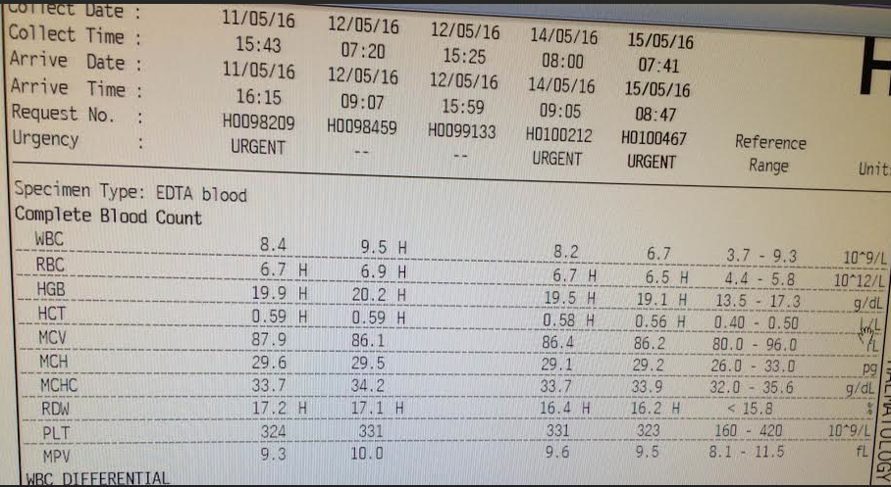

2. What is the term for the abnormality in blood picture?
Polycythaemia vera
3. Together with headache, blur vision, what syndrome shall we think of?
Hyperviscosity syndrome.

4. What are the causes for the syndrome? Name 3.
- Bone marrow hyperproliferative states, as follows:
- Leukemia
- Essential thrombocytosis
- Myelodysplastic disorders
- Multiple myeloma
5. What treatment shall be initiated in AED?
Intravenous fluid and aspirin.

6. What other treatment for the blood picture abnormality?
Venesection, hydroxyurea
Q5. M/37, smoker
Attended for epigastric pain, which is related to meal intake and is non-exertional
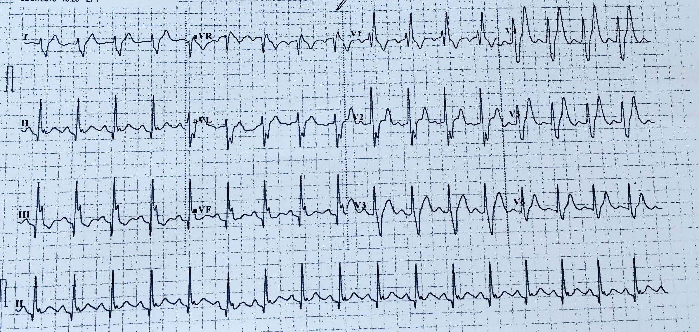
ECG was done at triage station:
1. Please describe the ECG.
Sinus tachycardia, RBBB, Q wave over inferior lead, prominent T waves over V3-V6

On further examination of the patient, we found
frontal baldness, temporalis wasting and muscle of mastication wasting bilaterally, no obvious ptosis but weakness when closing eye with resistance.

Upper limbs:
Bilateral muscle wasting especially over distal forearm and hand
Tone ↑↑ bilaterally
Power 5/5 proximally , 4/4 distally
Reflex ↓ over bicep reflex and supinator reflex
Sensation and propioception preserved

Lower limbs:
Bilateral distal muscle wasting
No fasciculation
Power 5/5 over proximal and distal muscle
Reflex normal over knee and ankle
Gait normal
TnI normal x 2 sets, CK 378 → 365→ 746

2. What is the likely diagnosis?
Muscular dystrophy.

3. How many types of the disease are present?
There are two main types of myotonic dystrophy. Myotonic dystrophy type 1 (DM1), also called Steinert disease. Myotonic dystrophy type 2 (DM2), also called proximal myotonic myopathy (PROMM) is rarer than DM1 and generally manifests with milder signs and symptoms.
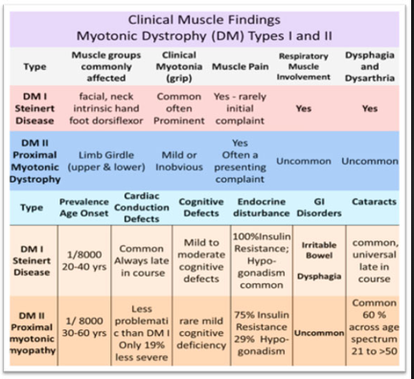

4. What is the form of genetic inheritance for this disease?
It is an autosomal-dominant type of genetic disease.

